ASSIGNMENT NUMBER 3

STATEMENT: Implement C++ program to create a base class called shape. Use
this class to store two double type values thatc ould be used to compute the area of figures.
Derive two specific classes called function get_data() to initialize base class data members
and another member function display_area() to compute and display the area of figures. Make
classes to suit their requirements. Using these three classes, design a program that will accept
dimension of a triangle or a rectangle interactively, and display the area. Remember the
two values given as input will be treated as lengths of two sides in the case of rectangles, and
as base and height in the case of triangles, and used as follows:
Area of rectangle= x*y
Area of triangle =1/2*x*y

AIM: To create a base class and derived classes tocalculate the area of triangle or rectangle.

DESCRIPTION: Create a base class shape which gets the input as dimensions of shape.
Ask user area of which shape is to be calculated and according to that call the function of
respective class and display the area.
OOP CONCEPT USED:
1. Class-:The building block of C++ that leads to Object Oriented programming is a Class. It is auser defined data type, which holds its own data members and member functions, which
can be accessed and used by creating an instance of that class. A class is like a blueprint
for an object.
2. Object-: An Object is an instance of a Class. When a class is defined, no memory is
allocated but when it is instantiated (i.e. an object is created) memory is allocated. In this
assignment, we created objects for all classes to use significantly to calculate the area of
shape.
SOURCE CODE:
#include<iostream>
using namespace std;

class Shape
{
public:

virtual void get_data()=0;
virtual void display_area()=0;
};

class Rectangle:public Shape
{
double a,b,area1;

public:

void get_data()
{
cout<<"\n ENTER THE LENGTH AND BREADTH OF RECTANGLE: ";
cin>>a>>b;
}
void display_area()
{
cout<<"\n LENGTH: "<<a;
cout<<"\n BREADTH: "<<b;
area1=a*b;
cout<<"\n AREA OF RECTANGLE IS: "<<area1;
}
};
class Traingle :public Shape
{
double a,b,area2;
public:

void get_data()
{
cout<<"\n ENTER THE BASE AND HEIGTH OF TRIANGLE:";
cin>>a>>b;
}
void display_area()
{
cout<<"\n BASE : "<<a;
cout<<"\n HEIGHT: "<<b;
area2=(0.5*(a*b));
cout<<"\n AREA OF TRIANGLE IS: "<<area2;
}
};
class Circle :public Shape
{
double r,area3;
public:

void get_data()
{
cout<<"\n ENTER THE RADIUS OF CIRCLE:";
cin>>r;
}
void display_area()
{
cout<<"\n RADIUS : "<<r;

area3=(3.14*(r*r));
cout<<"\n AREA OF CIRCLE IS: "<<area3;
}
};
int main()
{

Rectangle R;

Traingle T;

Circle C;

int ch;
do{
cout<<"\n ENTER YOUR CHOICE: ";
cout<<"\n 1. AREA OF RECTANGLE"<<"\n 2. AREA OF TRIANGLE"<<"\n 3.AREA OF CIRCLE"<<endl;
cin>>ch;

switch(ch)
{

case 1:
R.get_data();
R.display_area();
break;
case 2:
T.get_data();
T.display_area();
break;
case 3:
C.get_data();
C.display_area();
break;
default:
cout<<"\n INVALID CHOICE"<<endl;
}
}while(ch<4);

return 0;
}

OUTPUT:
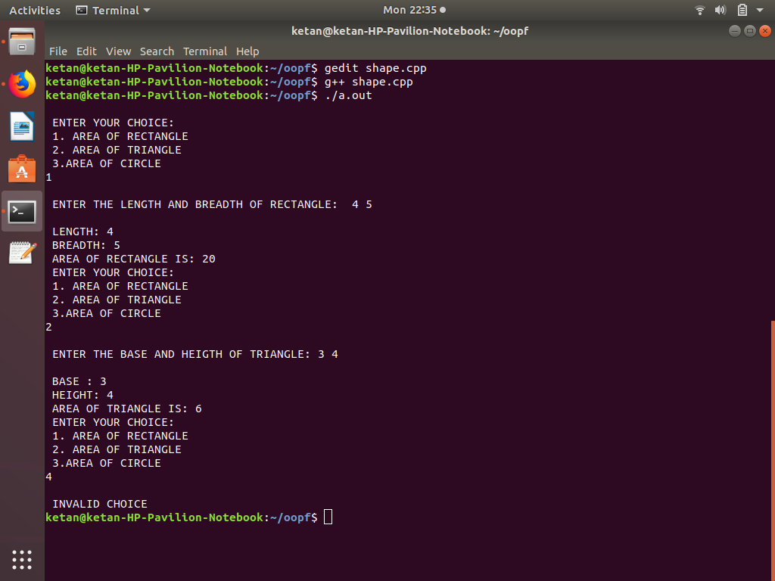

CONCLUSION: In this assignment, we learned the use of classes and objects in object oriented
programming.

